***OOP LAB ASSIGNMENT = 5***

Name :- Ankit Senjaliya

Enrollment No. :- 19BT04046

(1) Declare a class called logic_gate date to represent logic gate. The class has three data members - input1, input2 and input3 to represent three inputs to the logic gate. The class also has a virtual function member called get_gate_output. Derive two classes from the base class logic_gate, namely, and_gate and or_gate to represent ' logical and gate ' and ' logical or gate ' respectively. Define function get_gate_output in both of these classes to get the output of the gate. Show use of above classes and functions to demonstrate dynamic polymorphism in function main.

#include<iostream.h>

#include<conio.h>

class logic_gate

{

int in_1, in_2, in_3;

public:

logic_gate()

{

cout<<"\n\t Enter The Values In 1 Or 0 :- ";

cout<<"\n\n\t\t Enter The First Input = ";

cin>>in_1;

cout<<"\n\t\t Enter The Second Input = ";

cin>>in_2;

cout<<"\n\t\t Enter The Third Input = ";

cin>>in_3;

}

virtual void get_gate_output() = 0;

int in1()

{

return in_1;

}

int in2()

{

return in_2;

}

int in3()

{

return in_3;

}

};

class and_gate:public logic_gate

{

int out;

public:

void get_gate_output()

{

out = in1()*in2()*in3();

cout<<"\n\n\t Output Of Nand Gate Is = "<<out;

}

};

class or_gate:public logic_gate

{

int out;

public:

void get_gate_output()

{

out = in1() + in2() + in3();

if(out>0)

{

cout<<"\n\n\t Output Of Or Gate Is = 1 ";

}

else

{

cout<<"\n\n\t Output Of Or Gate Is = 0 ";

}

}

};

int main()

{

clrscr();

cout<<"\n Name :- Ankit Senjaliya ";

cout<<"\n Enrollment No. :- 19BT04046 \n\n";

and_gate a;

or_gate o;

a.get_gate_output();

o.get_gate_output();

getch();

return 0;

}

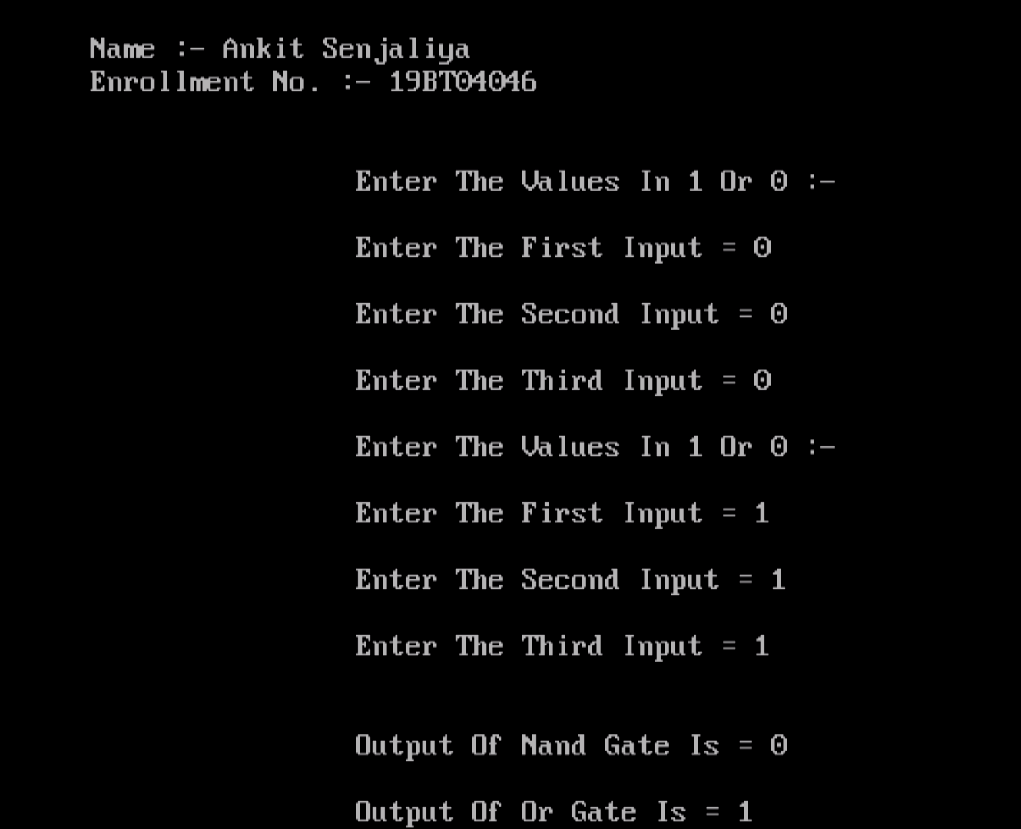

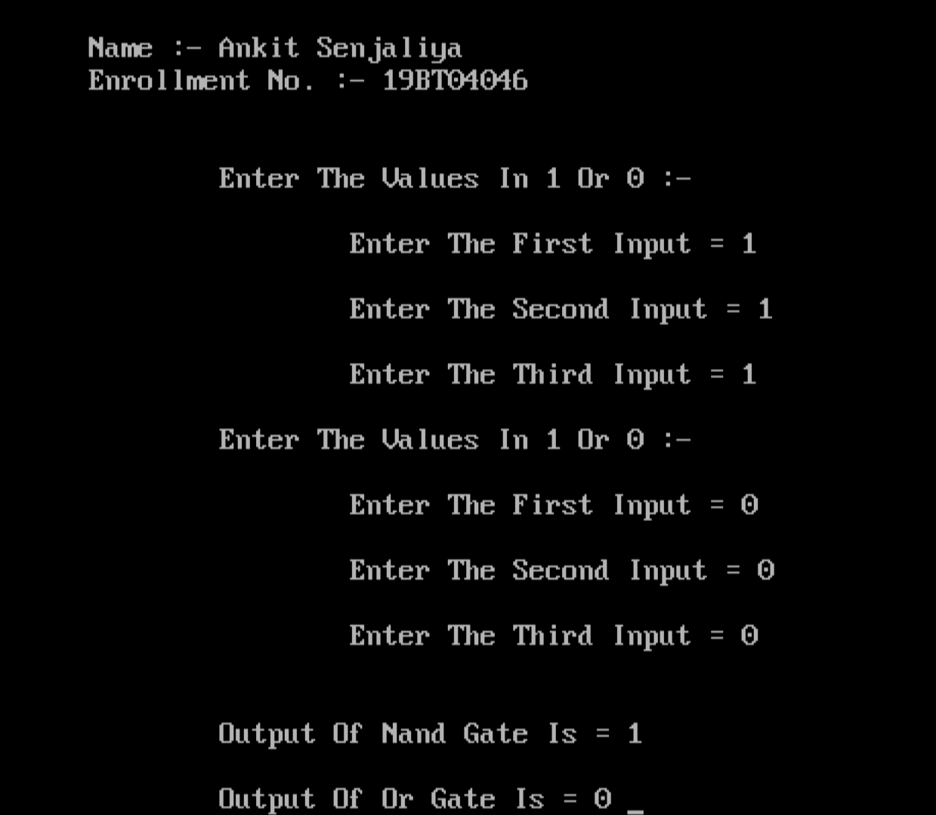

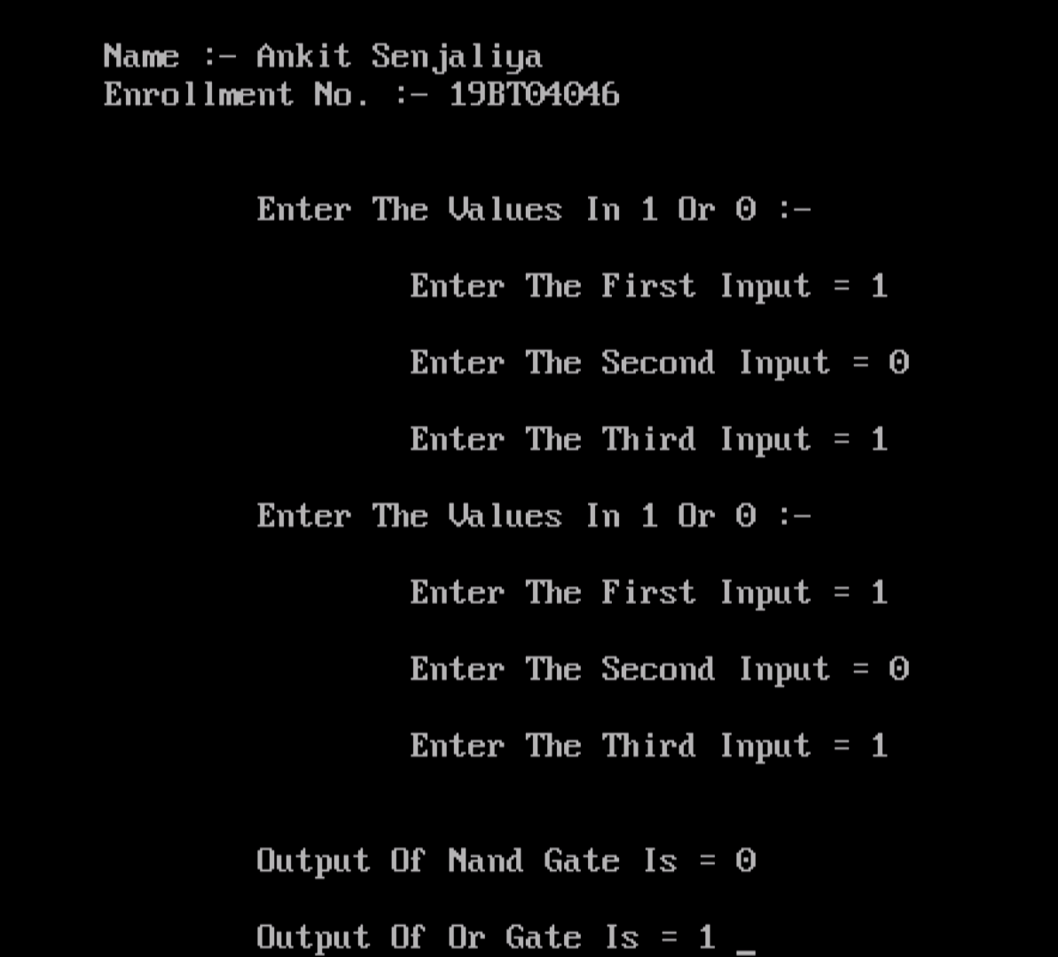

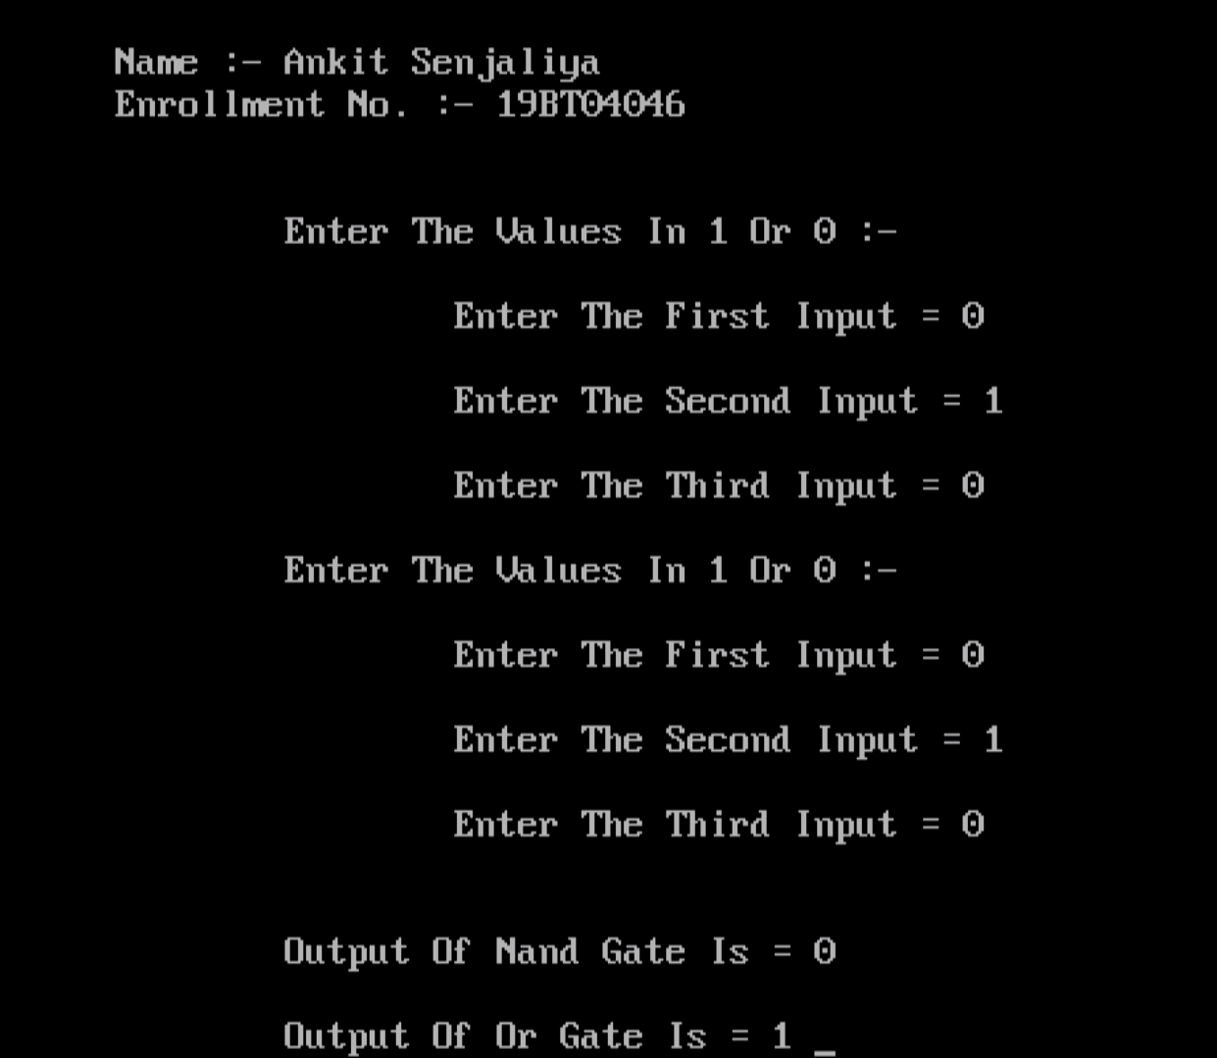

(2) Declare a class called item having data members item_code, item_name, cost, and discount. Derive two classes from class item, namely employee and coustmer. The class employee has data members like customer_name and amount. Define following functions for - initializing data members. - displaying the values of data members. - computing amount to be paid for a purchased item. Also define function main to create objects of both derived classes and to show usage of above functions.

#include<iostream.h>

#include<conio.h>

class item

{

int it_code;

char *it_name;

float it_price;

float it_discount;

public:

item()

{

cout<<"\n\t Enter Item Code = ";

cin>>it_code;

cout<<" Enter The Name Of Item = ";

cin>>it_name;

cout<<" Enter The Price Of Item = ";

cin>>it_price;

cout<<" Enter The Amount Of Discount On Item = ";

cin>>it_discount;

}

int get_code()

{

return it_code;

}

char* get_name()

{

return it_name;

}

float get_price()

{

return it_price;

}

float get_discount()

{

return it_discount;

}

};

class employee:public item

{

int emp_code;

char *emp_name;

int emp_amount;

public:

employee()

{

cout<<"\n\t Enter The Employee Code = ";

cin>>emp_code;

cout<<" Enter The Name Of Employee = ";

cin>>emp_name;

cout<<" Enter The Amount To Be Payed = ";

cin>>emp_amount;

}

};

class customer:public item

{

char *cus_name;

int no_item;

public:

customer()

{

cout<<"\n\t Enter The Name Of Cousomer = ";

cin>>cus_name;

cout<<"\n\t Enter The Number Of Item To Be Purchacs = ";

cin>>no_item;

}

void total_amount()

{

int tot_amount;

tot_amount = no_item*get_price();

cout<<"\n\t Total Amount To Be Payed By Coustomer = "<<tot_amount;

}

};

int main()

{

clrscr();

cout<<"\n Name :- Ankit Senjaliya ";

cout<<"\n Enrollment No. :- 19BT04046 \n\n ";

employee e;

customer c;

c.total_amount();

getch();

return 0;

}

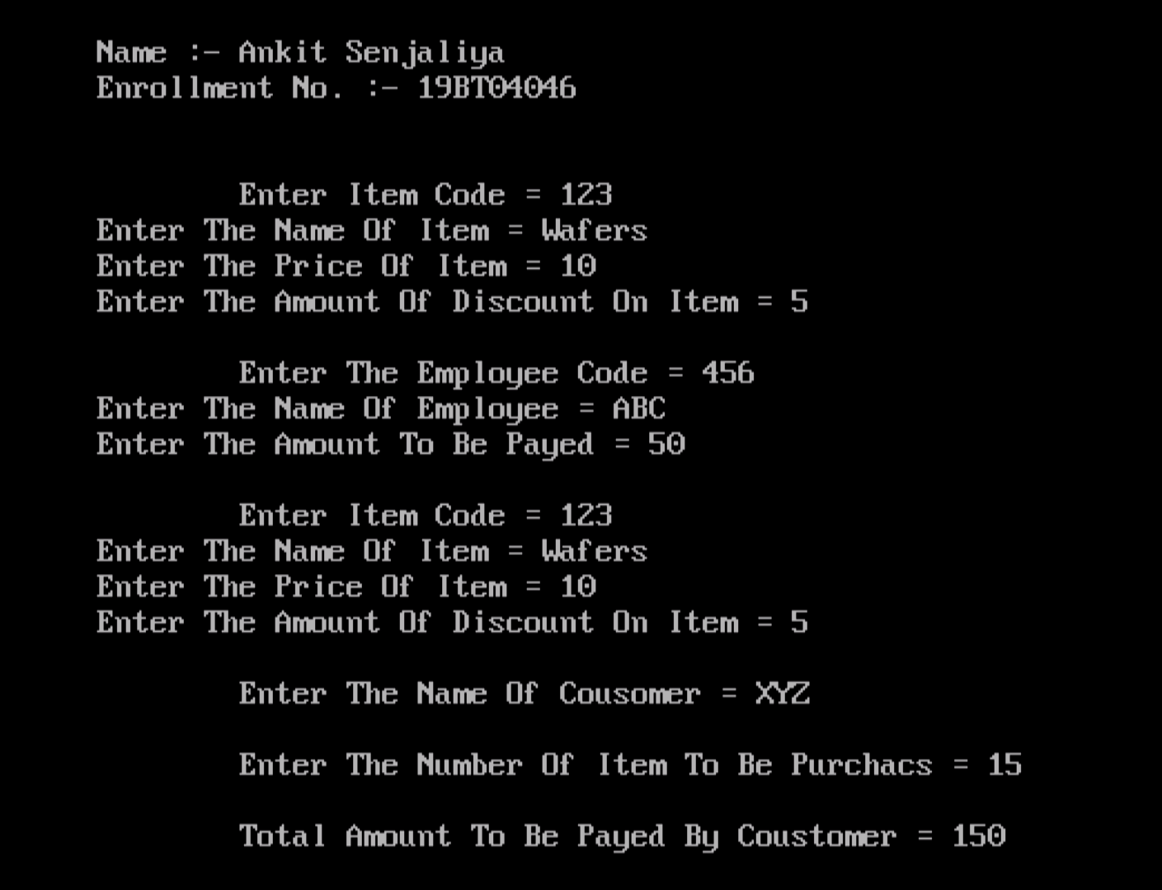

(3) Write a c++ program to swap two no's using Function template.

#include<iostream.h>

#include<conio.h>

template <class T>

void swap(T &x, T &y)

{

T temp;

temp = x;

x = y;

y = temp;

}

int main()

{

clrscr();

cout<<"\n\n\t\t\t Name :- Ankit Senjaliya ";

cout<<"\n\n\t\t\t Enrollment No. :- 19BT04046 \n\n";

int x,y;

cout<<"\n\t\t\t Enter The First Number = ";

cin>>x;

cout<<"\n\t\t\t Enter The Second Number = ";

cin>>y;

cout<<"\n\n\t\t\t Before Swap = ";

cout<<"\n\n\t\t\t Value Of X = "<<x;

cout<<"\n\n\t\t\t Value Of Y = "<<y;

swap(x,y);

cout<<"\n\n\t\t\t After Function Template = ";

cout<<"\n\n\t\t\t Value Of X = "<<x;

cout<<"\n\n\t\t\t Value Of Y = "<<y;

getch();

return 0;

}

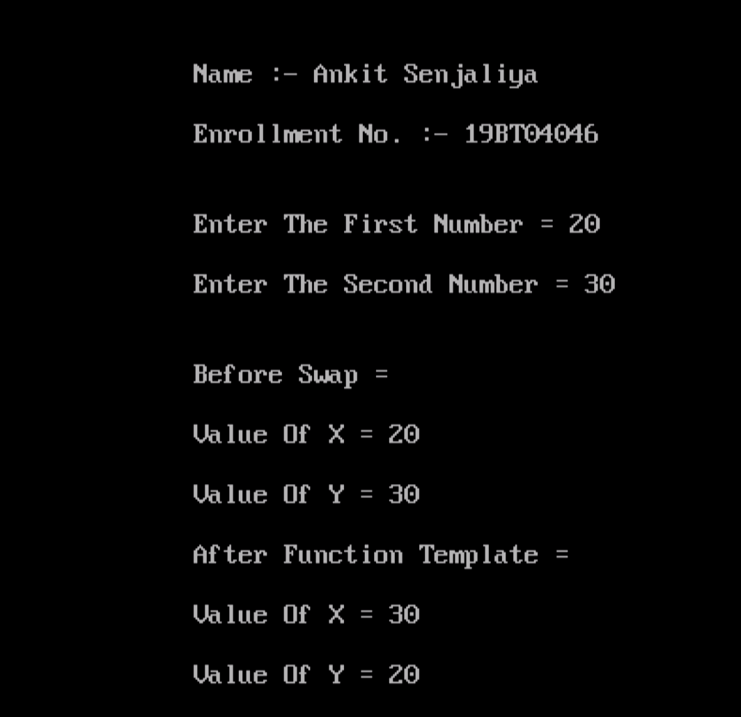

(4) Create a generalized class stack using class template and implement common push and pop operation and different data types.

#include<iostream.h>

#include<conio.h>

#define MAX 30

template <class T>

class stack

{

protected:

T arr[MAX];

public:

T item,r;

int top;

stack()

{

for(int i=0;i<MAX;i++)

{

arr[i] = NULL;

}

top = -1;

}

void push(T a)

{

top++;

if(top<MAX)

{

arr[top] = a;

}

else

{

cout<<"\n\n\t\t\t Stack Is Full ";

top--;

}

}

T pop()

{

if(top==-1)

{

cout<<"\n\n\t\t\t Stack Is Empty ";

return NULL;

}

else

{

T data = arr[top];

arr[top] = NULL;

top--;

return data;

}

}

};

int main()

{

stack<int> a;

int opt = 1;

while(opt!=3)

{

clrscr();

cout<<"\n\n\t\t\t Name :- Ankit Senjaliya ";

cout<<"\n\n\t\t\t Enrollment No. :- 19BT04046 \n\n";

cout<<"\n\n\t\t\t Max Stack Capacity = "<<((MAX - a.top) - 1);

cout<<"\n\n\t\t\t 1 = Pop Item ";

cout<<"\n\n\t\t\t 2 = Push Item ";

cout<<"\n\n\t\t\t 3 = Exit ";

cout<<"\n\n\t\t\t Enter Your Choice = ";

cin>>opt;

switch(opt)

{

case 1 :

cout<<"\n\n\t\t\t Which Number Should Be Pushed ?? ";

cin>>a.item;

a.push(a.item);

break;

case 2 :

a.r = a.pop();

cout<<"\n\n\t\t\t Item Popped From Stack Is = "<<a.r;

break;

getch();

return 0;

}

}

}

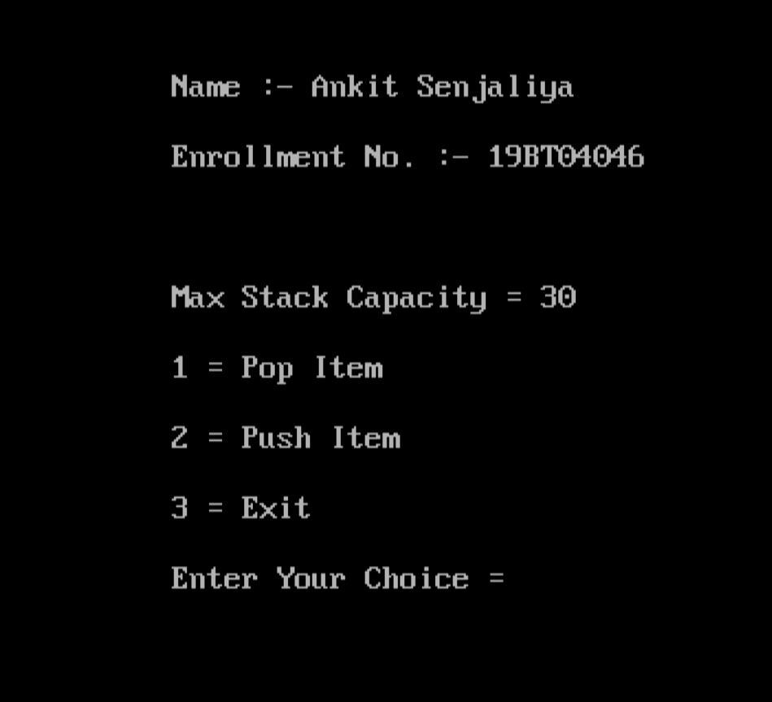

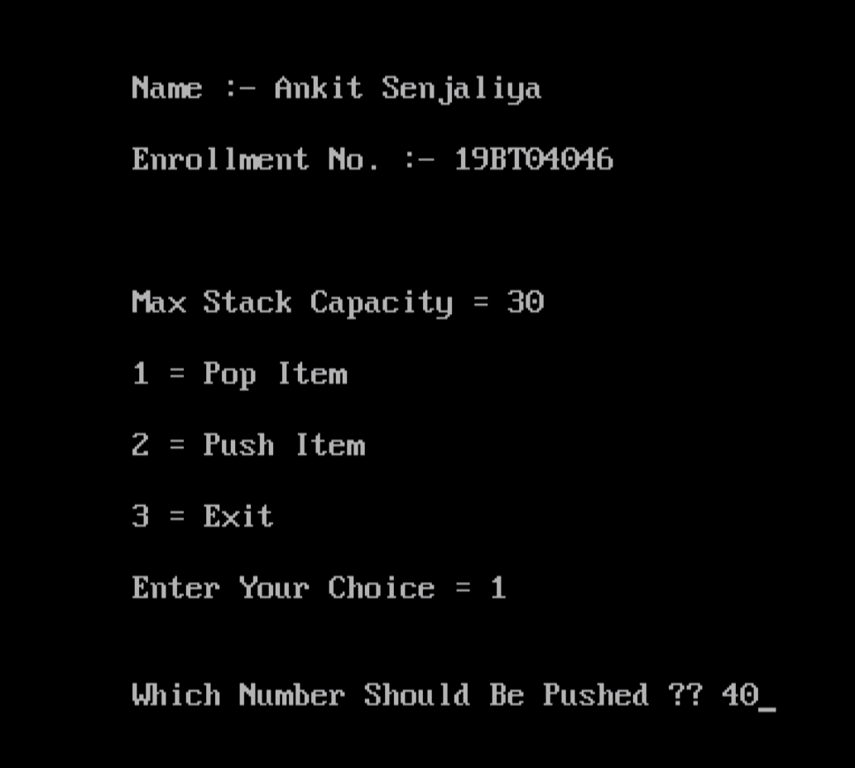

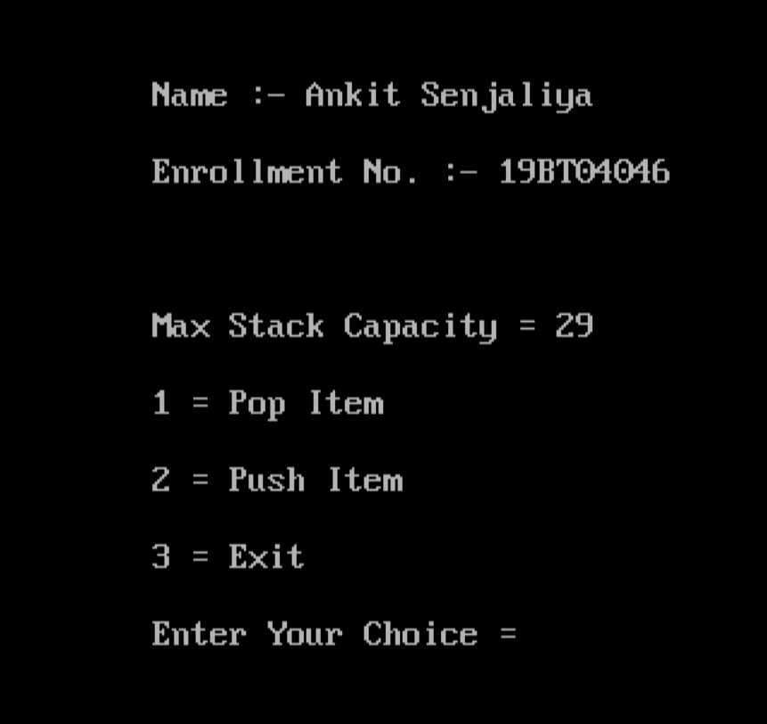

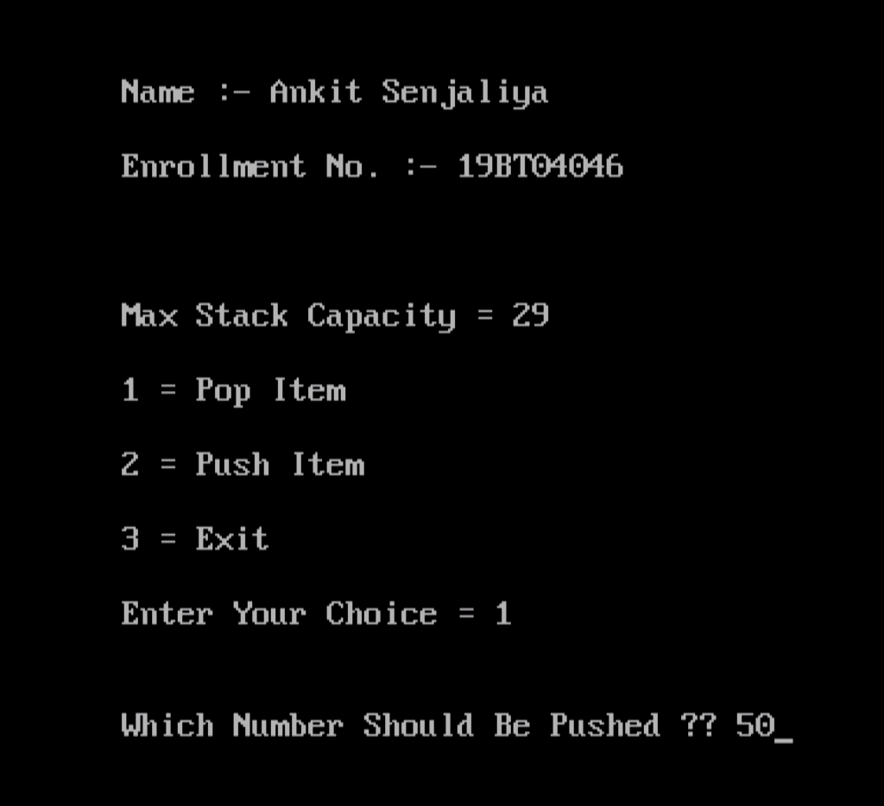

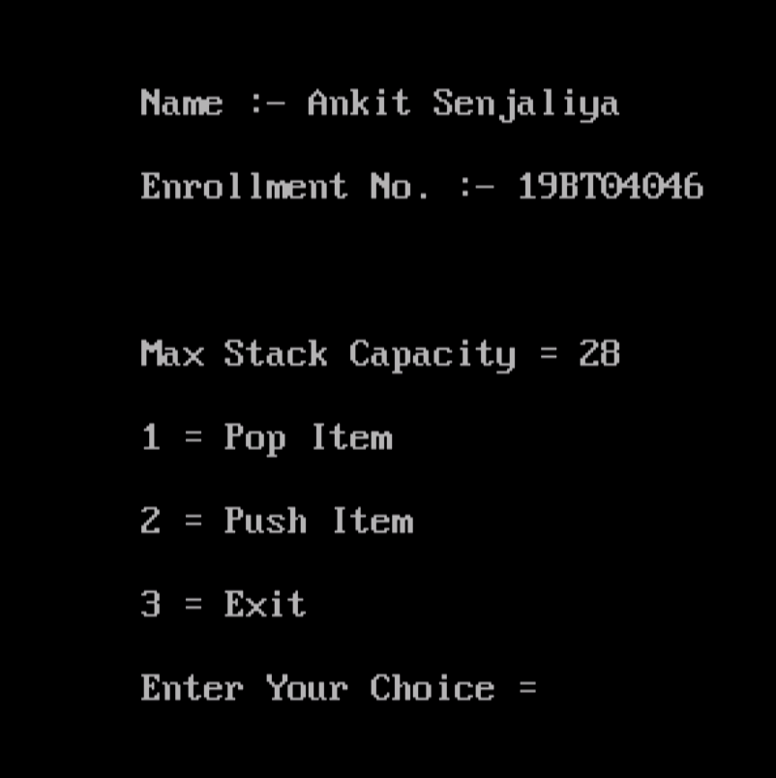

(5) Any management System ( Hospital, Bank, Hotel Booking, Traveling, E-commerce, Employee Management etc )

* Bank Management System :-

#include<iostream.h>

#include<conio.h>

class bank

{

private:

char name[20];

int acc_no;

float balance;

public:

void open(void);

void deposite(int);

void withdraw(int);

void search(int);

void display(void);

};

void bank::open(void)

{

cout<<"Enter Your Name = ";

cin>>name;

cout<<"Enter Your Account Number = ";

cin>>acc_no;

cout<<"Enter The Amount Of Money = ";

cin>>balance;

}

void bank::deposite(int)

{

int bnc,j;

if(acc_no==j)

{

cout<<"Enter The Amount Of Money = ";

cin>>bnc;

balance=balance+bnc;

cout<<"\n\n\t Job Has Done Well !!! \n";

}

}

void bank::withdraw(int k)

{

int blnc, p;

if(acc_no==k)

{

cout<<" Your Current Account Balance Is :- "<<balance;

cout<<"\n The Amount Of Money You WantTo Withdraw Is :- ";

cin>>blnc;

p=balance-blnc;

{

if(p<0)

cout<<"Sorry !!! There Is Not Enough Money In Your Account \n";

else if(p>=0)

{

cout<<"\n\t Your Request To Withdraw Money Has Done... \n\n";

balance = p;

}

}

}

}

void bank::display(void)

{

cout<<"\n\n Name = "<<name;

cout<<"\n\n Account No. = "<<acc_no;

cout<<"\n\n Balance = "<<balance<<"\n\n";

}

void bank::search(int m)

{

if(acc_no==m)

{

cout<<"\n\n****** Account Holder's Information ****** ";

cout<<"\n\n Name = "<<name;

cout<<"\n\n Account No. = "<<acc_no;

cout<<"\n\n Balance : BDT = "<<balance<<"\n\n";

cout<<"\n*******************************************\n\n";

}

}

void main()

{

int i,j,k,m,l,y=0;

bank b[30];

int index;

clrscr();

cout<<"\n Name = Ankit Senjaliya ";

cout<<"\n Enrollment No. :- 19BT04046 \n\n";

do

{

cout<<"\n Press 1 To Open Account \n";

cout<<" Press 2 To Deposite Amount \n";

cout<<" Press 3 To Withdraw Money \n";

cout<<" Press 4 To Display \n";

cout<<" Press 5 To Search \n";

cout<<" Press 6 To Exit \n\n\t\n";

cout<<" Your Option Choice = ";

cin>>index;

switch(index)

{

case 1 :

cout<<"\n How Many Account You Want To Open ? \n = "<<" ";

cin>>y;

for(i=0;i<y;i++)

{

b[i].open();

}

break;

case 2 :

cout<<"\n Enter Your Account No = "<<" ";

cin>>j;

for(i=0;i<y;i++)

{

b[i].deposite(j);

}

break;

case 3 :

cout<<"\n Enter Your Account No = "<<" ";

cin>>k;

for(i=0;i<y;i++)

{

b[i].withdraw(k);

}

break;

case 4 :

for(i=0;i<y;i++)

{

b[i].display();

}

break;

case 5 :

cout<<"\n Enter Your Account No = "<<" ";

cin>>m;

for(i=0;i<y;i++)

{

b[i].search(m);

}

break;

case 6 :

break;

default:

cout<<"\n You Have Pressed The Wrong Key. Please Try Again... \n\n\n";

break;

}

}

while(index!= 6);

}

